

ANOREXIA

WHAT REALLY MEANS ANOREXIA

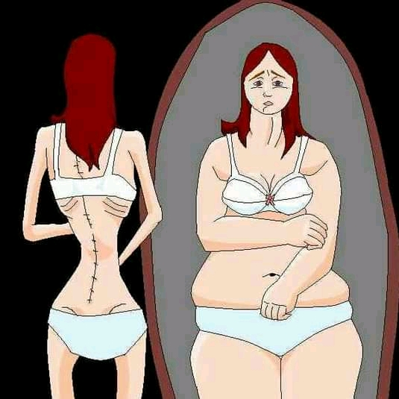

**STUDENT: ISIDORA VAN-DÚNEM**

THANKS AND GREETING……………………………………………………………………………………1

ATTETION GRABBER………………………………………………………………………………………….2

INTRODUCTION………………………………………………………………………………………………..3

DEVELOPMENT………………………………………………………………………………………………….4

THE MEDIA CAN INFLUENCE IN THIS DISEASE…………………………………………………..4

CONSEQUENCES……………………………………………………………………………………………….4

HOW I CAN HELP IF I SUSPECT SOMEONE HAS ANOREXIA……………………………….5

CONCLUSION

**THANKS AND GREETINGS**

FIRST I WANT TO THANK GOD FOR ENABLING ME TO DO THIS AND I ALSO THANK MY MOTHER FOR GIVING ME THE OPPORTUNITY TO LEARN ENGLISH AND MY TEACH FOR TEACHING ME AND ACCOMPANYING ME ON THIS JOURNEY.

**ATTETION GRABBER**

THRERE WAS A WOMAN NAMED GRACE SHE HAD AN OBSSESSION FOR THE PERFECT BODY. BASED ON HER FAKE IMAGE ABOUT HER SELF SHE START TO EAT LESS AND LESS , WHENEVER SHE ATE SOMETHING, SHE USE TO PROVOKE VOMITS JUST TO AVOID GET FAT.

THAT OBSSESSION EVENTUALLY LED HER TO DEVELOP ANOREXIA

WHAT ANOREXIA REALLY MEANS .

**INTRODUCTION**

ANOREXIA IT´S A MENTAL DISEASE WHERE YOU SEE YOURSELF HAS TOO FAT , EVEN THOUGT YOU AREN T. ANOREXIA IS ALSO AN EATING DISORDER DUE TO WHICH A PERSON BECOMES EXTREMELY IRRITIONAL AND FEARFUL ABOUT THEY BODY AND OF BECOMING FAT. ANOREXIA CAN AFFECT PEOPLE OF ALL AGES , GENDERS , SEXUAL ORIENTATIONS AND RACES. THE PERSON LOOKS IN THE MIRROR AND ALTHOUGH EXTREMELY THIN SEEMS HIMSELF OBESE. AFRAID OF GAINING WEIGHT , HE EXAGGERATES PHYSICAL ACTIVITY FASTS, FASTS , VOMITS.

**DEVELOPMENT**

**HOW THE MEDIA CAN INFLUENCE IN THIS DISEASE.**

THE MEDIA PORTRAY A FALSE VIEW OF WHAT PEOPLE TRULY LOOK LIKE . IN MAGAZINES, MOVIES AND EVEN ON BILLBOARDS MOST OF ACTORS-MODELS ARE DIGITALLY ALTERED IN MULTIPLE WAYS.THEN PEOPLE STRIVE TO LOOK LIKE THESE ´´PERFECT´´ MODELS WHEN IN REALITY THEY AREN´T NEAR OF PERFECTION.

**CONSEQUENCES**

**WHAT ARE THESE CONSEQUENCES**

THESE CONSEQUENCES ARE

. FEELING COLD ALL THE TIME

. SLEEP PROBLEMS.

. MENSTRUAL IRREGULARITIES

. TOOTH SENSITIVE

. MUSCLE WEAKNESS

. AND YELLOW SKIN

**HOW CAN HELP IF I SUSPECT SOMEONE HAS ANOREXIA NERVOSA**.

IF YOU SUSPECT THAT SOMEONE YOU KNOW HAS ANOREXIA OR IS SHOWING SIGNS, TALK TO THEN AND CONVINCE THEN TO SEEK PROFESSIONAL HELP. IF THEY AREN´T WILLING TO DISCUSS THEIR EATING PROBLEMS WITH YOU , OR BECOME AGGRESSIVE, SUGGEST ASKING THEM TO READ ABOUT THE CONDITION.THIS MIGHT HELP TO FAMILIARISE THEM WITH SOME OF THE TERMINOLOGY AND WILL ALSO MAKE THEM AWARE OF THE DANGERS INVOLVED.

**CONCLUSION**

TALK TO THE PERSON AND FIND OUT THEIR THOUGH OR REASONS INVOLVED IN THAT SITUATION .

-DON´T JUDGE, DON´T BLAME ,INSTEAD SAY THINGS LIKE ´AM CONCERNED ABOUT YOU´´ AND DO WHEREVER YOU CAN IN ORDER TO HELP THAT PERSON.

-DON´T GIVE SIMPLE SOLUTION . DON´T SAY . ´´IF YOU´D JUST STOP , THEN THINGS WOULD BE FINE.

DON´T WAIT ANY LONGER ,SEEK FOR PROFISSIONAL HELP.

ANOREXIA MAY CAUSE DAMAGE THAT SEEM INSUPERABLE. BUT, LOVE AND SUPPORT FIX EVERYTHIN.

THANK YOU SO MUCH.